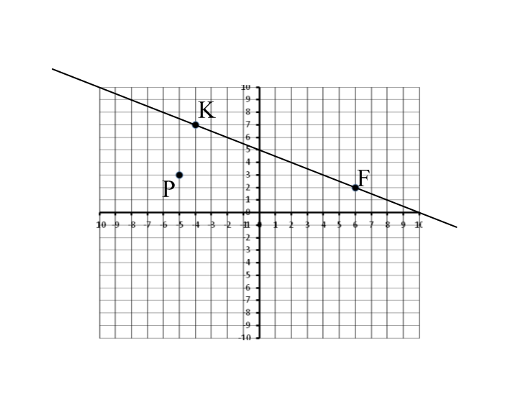
Math 10C Name: _______________________________
Slopes, Equations and Points Date: _______________________________
- Given the line KF:

- Find the slope of KF.
- Draw a line through point P that is parallel to KF.
- What is the equation of line KF? Use the Ax+By+C=0 format.
- Solve the following to find points on the line:
- If x =0
- If y =0
- Rearrange the equation so it is in the format: y =

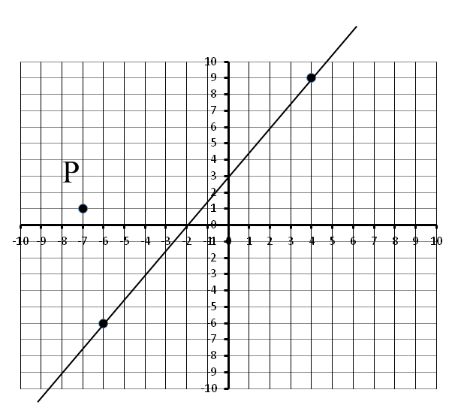
- Given the line.

- Find the slope.
- Draw a line through point P that is parallel to the given line.
- What is the equation of the given line? Use the Ax+By+C=0 format.
- Solve the following to find points on the line:
  - If x =0
  - If y =0
- Rearrange the equation so it is in the format: y =

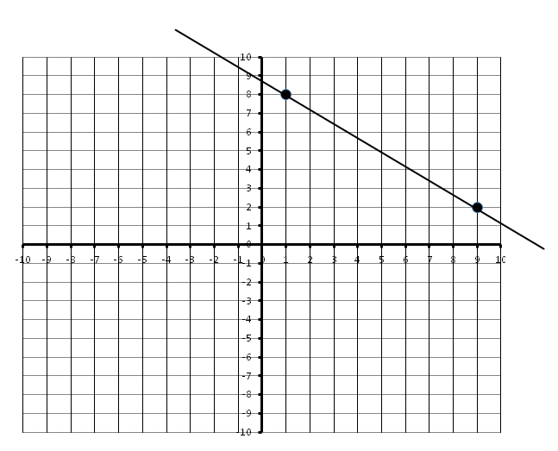
- Given the line passing through two points (1,8) and (9,2).

- Find the slope.
- What would the slope of a line perpendicular to the given line?
- Draw a line through point P (0,4) that is perpendicular to the given line.
- What is the equation of the line through P? Use the Ax+By+C=0 format.
- Solve the following to find points on the line:
  - If x =0
  - If y =0
- Rearrange the equation so it is in the format: y =

- Given two points (-4,-8) and (-1,-4).
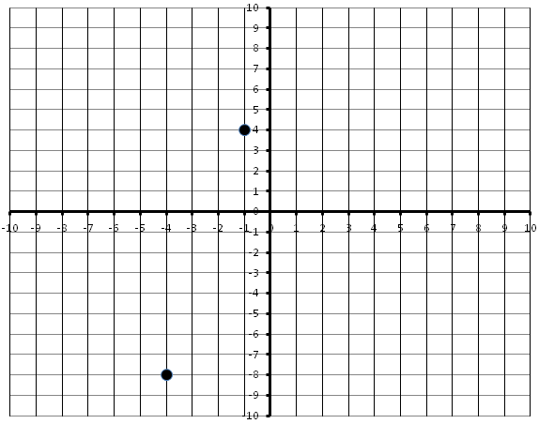
- Find the slope of the line joining these two points.
- What is the slope of a line perpendicular to a line through the given points?
- Draw a line through point P (-8,4) that is perpendicular to a line through the given points.
- What is the equation of the line through P? Use the Ax+By+C=0 format.
- Solve the following to find points on the line:
  - If x =0
  - If y =0
- Rearrange the equation so it is in the format: y =

