developing a system of equations
Consider the following:
Wolf Creek Public Schools has busses that carry 12 passengers and buses that carry 24 passengers. The total passenger capacity is 780. There are 20 more small buses than large buses. How many of each type of bus does Wolf Creek Public Schools own?

- What are the unknown quantities?

- Identify some variables to represent these unknown quantities.

- Develop two equations that could be used to model the information given in the problem.

Two equations are said to form a “system of equations” in two variables. A system of linear equations is referred to as a “linear system”.
The solution to the linear system is a pair of values for the variables that satisfy BOTH equations.

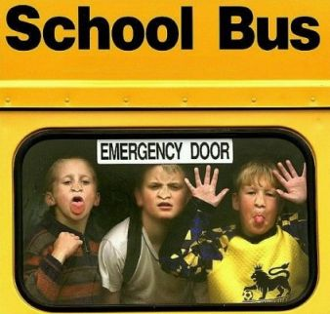
- Suppose you are told that there are 35 small buses and 15 large buses. Could this be a possible solution to the problem? How could you verify this answer?

The stage at the Lyle Victor Albert Centre in Bonnyville, Alberta, is rectangular. Its perimeter is
158 ft. The width of the stage is 31 ft less than the length.

- Identify some variables to represent the unknown quanities in the problem.

- Create a linear system to model this situation.

- Michael determined that the stage is 55 ft long and 24 ft wide. Use the linear system you created to verify that Michael is correct.

The EnviroClub raised $140 by collecting 2000 cans and glass bottles for recycling. The club received 5¢ for a can and 10¢ for a bottle.

- Identify some variables to represent the unknown quantities in the problem.

- Create a linear system to model this situation.

- The club collected 1200 cans and 800 bottles. Use the linear system you created to verify these numbers.

A bicycle has two wheels and a tricycle has 3 wheels.

- Create a situation about wheels that can be modeled by the linear system below.

- Explain the meaning of each variable.

- Can you solve the problem?

