**Math 10C – Practice Assignment 1 Name: _________________________**

1. Identify the categories in the char and place the numbers in their best category.

-4    

    “5x2-10”

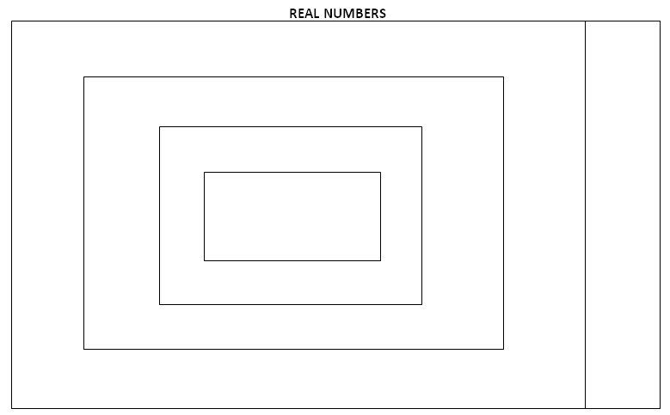

1. List the first 10 perfect square numbers:
2. List the first 5 perfect cube numbers:
3. Show the work that would complete the following changes from mixed to whole or whole to mixed radicals. You can use prime number skills or use perfect square/cube skills.
4. 
5. 
6. 
7. Change the following radicals to mixed radicals in simplest form. You must show work.
8. 
9. 
10. 
11. 
12. 
13. Change the following from mixed radicals to whole radicals.
14. 
15. 