Math 10C Name: __________________________
Trigonometry Notes

Pythagorean Theorem
In a right triangle the square of the hypotenuse longest side is equal to the sum of the square of the other two sides.
The formula is: $a^{2}+b^{2}=c^{2}$

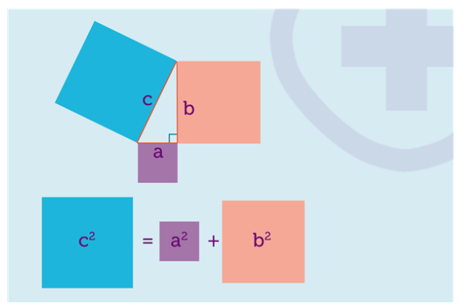
The hypotenuse of a right triangle is always the side opposite the right angle. It is the longest side in a right triangle.
The hypotenuse of a right triangle is always the side opposite the right angle. It is the longest side in a right triangle.
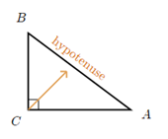

1. When working with the Pythagorean Theorem, we are always finding the length of one side.
If you are looking for the HYPOTENUSE use the formula:

$$a^{2}+b^{2}=c^{2}$$

For ANY other side, use the formula:

$c^{2}-b^{2}=a^{2}$

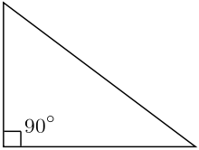
- For trigonometry, we need to not only identify the hypotenuse but which side is OPPOSITE the angle being studied and which side is ADJACENT.

The opposite side is across from a given angle. Adjacent is the whatever side is left.

In trigonometry, we MUST be given at least one angle and one side and we’re asked to find another side OR we’re given two sides and we’re asked to find an angle. Both situations require a different method of calculation.

First, you MUST know the trigonometry rations:
SOH CAH TOA

$\sin{θ=\frac{opposite}{hypotenuse}}$ $sinθ=\frac{o}{h}$

$\cos{θ=\frac{adjacent}{hypotenuse}}$ $cosθ=\frac{a}{h}$

$\tan{θ=\frac{opposite}{adjacent}}$ $tanθ=\frac{o}{a}$

